RandomForest classification of Kddcup data

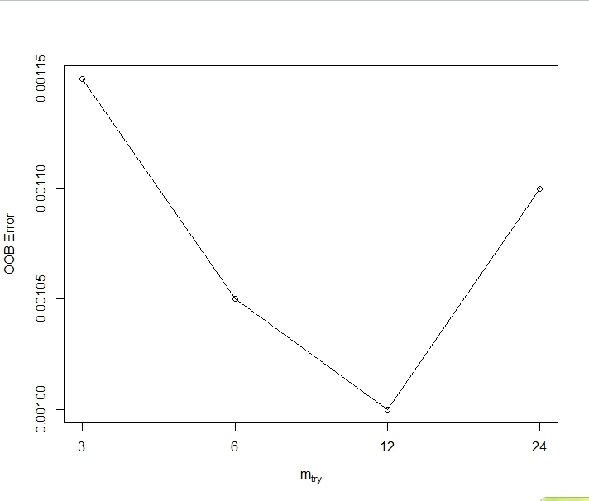

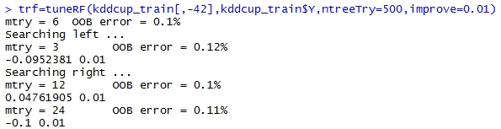

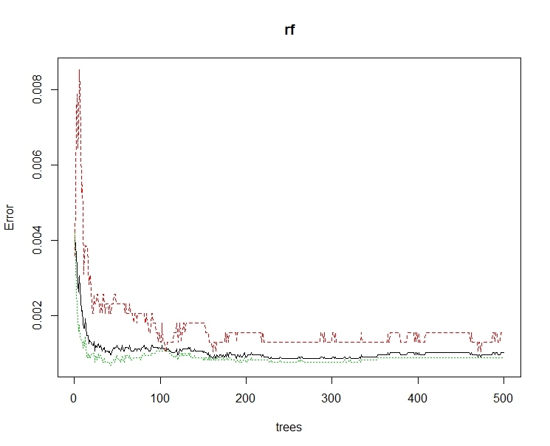

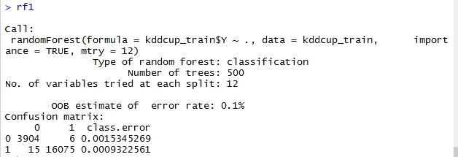

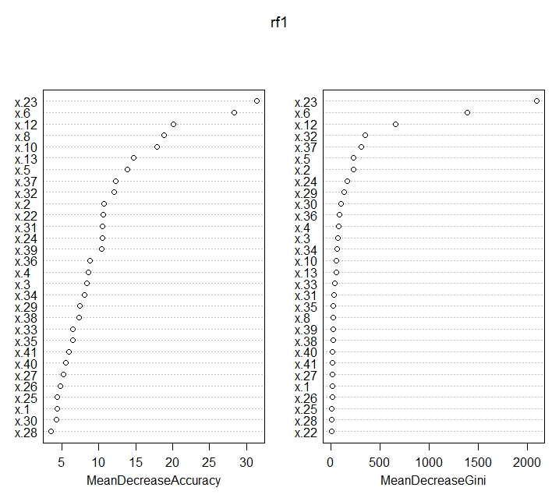

> run_time

user system elapsed

0.20 0.12 2.39

> error_rate

[1] 0.0026

## Code Appendix

# random forest classification of the kddcup data

library("randomForest", lib.loc="~/R/win-library/3.2")

kddcup <- read.csv("C:/Users/Christina/Desktop/kddcup.data_10_percent_corrected", header=FALSE)

kddcup=as.matrix(kddcup)

kddcup_1=sample((nrow(kddcup)),size=20000,replace = FALSE, prob = NULL)

kddcup_2=sample((nrow(kddcup)),size=5000,replace = FALSE, prob = NULL)

#Process of the data

kddcup_train=kddcup[kddcup_1,]

kddcup_test=kddcup[kddcup_2,]

for (i in 1:5000){

if (kddcup_test[i,42]=="normal."){

kddcup_test[i,42]=0}

else{

kddcup_test[i,42]=1

}

}

for (i in 1:20000){

if (kddcup_train[i,42]=="normal."){

kddcup_train[i,42]=0}

else{

kddcup_train[i,42]=1

}

}

kddcup_train=as.data.frame(kddcup_train)

kddcup_test=as.data.frame(kddcup_test)

for (i in 1:41){

kddcup_train[,i]=as.numeric(kddcup_train[,i])

kddcup_test[,i]=as.numeric(kddcup_test[,i])

}

kddcup_test[,42]=as.factor(kddcup_test[,42])

kddcup_train[,42]=as.factor(kddcup_train[,42])

colnames(kddcup_train)=c(paste("x.",1:41,sep=""),"Y")

colnames(kddcup_test)=c(paste("x.",1:41,sep=""),"Y")

#build the model

rf=randomForest(kddcup_train$Y~.,kddcup_train,importance=TRUE)

plot(rf,type="p",cex=0.5)

print(rf)

imp=importance(rf)

varImpPlot(rf)

#find the optimal mtry paraeter

trf=tuneRF(kddcup_train[,-42],kddcup_train$Y,ntreeTry=500,improve=0.01)

#we find that the optimal mtry is 12

rf1=randomForest(kddcup_train$Y~.,kddcup_train,importance=TRUE,mtry=12)

rf1

varImpPlot(rf1)

start_time=proc.time()

pre_test=predict(rf1,kddcup_test[,-42])

end_time=proc.time()

run_time=end_time-start_time

error_rate=sum(pre_test!=kddcup_test$Y)/nrow(kddcup_test)